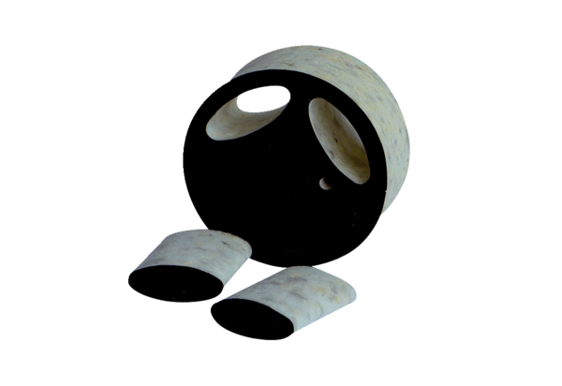Slide-in sound absorber SDE 16Packing unit: 1 pieceRange: C
Article number: 0044.0216Manufacturer: Jeven

