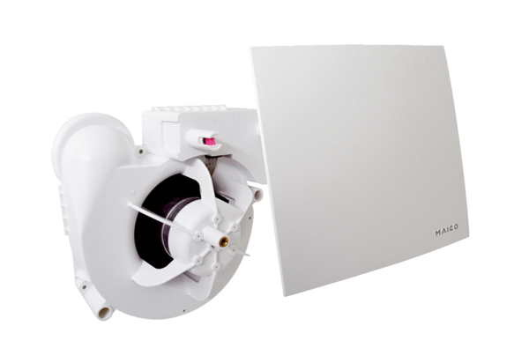Fan insert ER 100 EVZPacking unit: 1 pieceRange:
Article number: 0084.0381Manufacturer: MAICO

