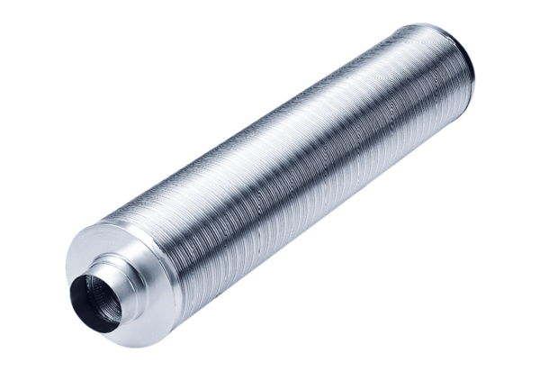Tubular sound absorber RSR 25/50Packing unit: 1 pieceRange: C
Article number: 0092.0327Manufacturer: MAICO

