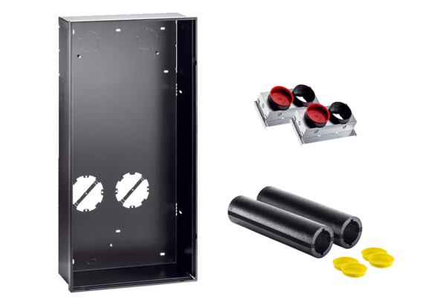shell installation kit WS 75 RSUPPacking unit: 1 pieceRange: K
Article number: 0093.1616Manufacturer: MAICO

