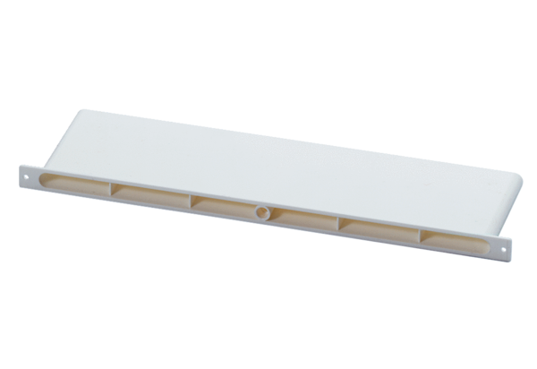Supply air channel ZEK 45 FPacking unit: 1 pieceRange: D
Article number: 0152.0050Manufacturer: MAICO

