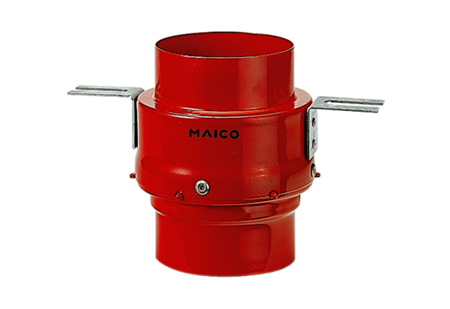Fire protection ceiling barrier TS 18 DN 100Packing unit: 1 pieceRange: B
Article number: 0151.0320Manufacturer: MAICO

