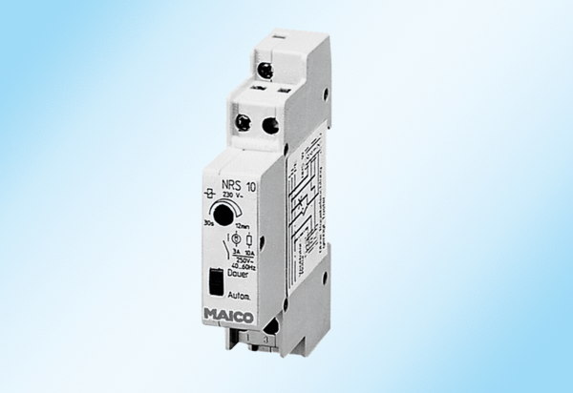Follow-up relay NRS 10Packing unit: 1 pieceRange: A
Article number: 0157.0747Manufacturer: MAICO

