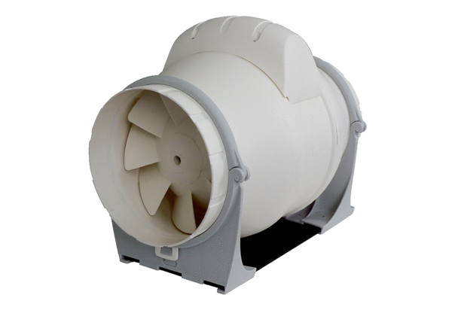Diagonal fan ERK 100 STPacking unit: 1 pieceRange: C
Article number: 0080.0176Manufacturer: MAICO

