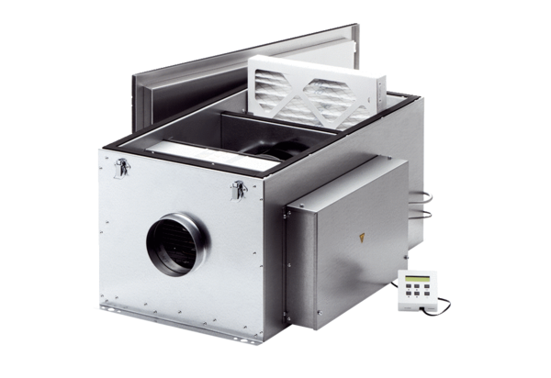Compact box ECR 20 ECPacking unit: 1 pieceRange: E
Article number: 0080.0576Manufacturer: MAICO

