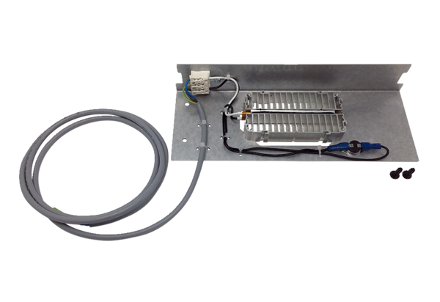Supplementary heating WS 75 NHPacking unit: 1 pieceRange: K
Article number: 0093.1586Manufacturer: MAICO

