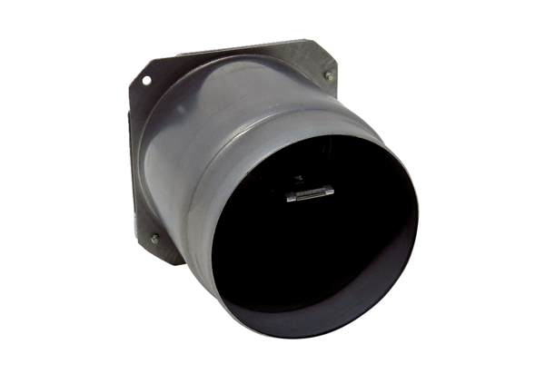Exhaust socket with pre-assembled backflow preventer ABSM RK ER-UPD/-UPBRange: B
Article number: E093.0977.0001Manufacturer: MAICO

