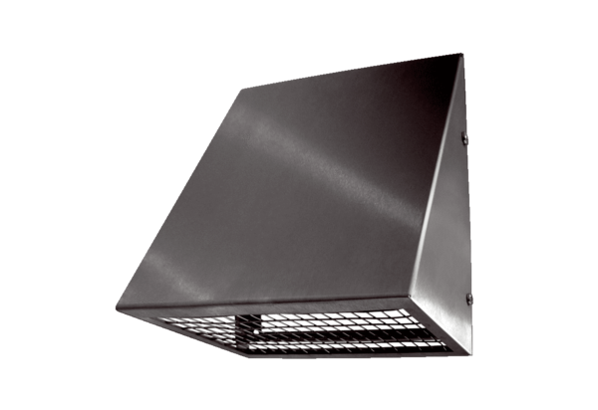Outside air wall connection KW-AL 20EPacking unit: 1 pieceRange: K
Article number: 0152.0081Manufacturer: MAICO

