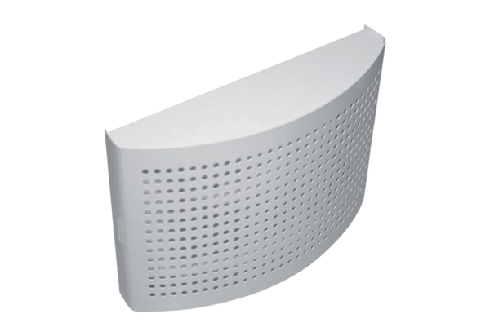Supply air valve ZWVQ 12Packing unit: 1 pieceRange: K
Article number: 0152.0065Manufacturer: MAICO

