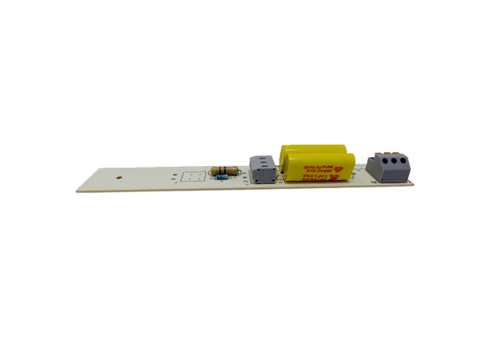Circuit board PL ECA 150 iproRange: A
Article number: E101.1410.0000Manufacturer: MAICO

