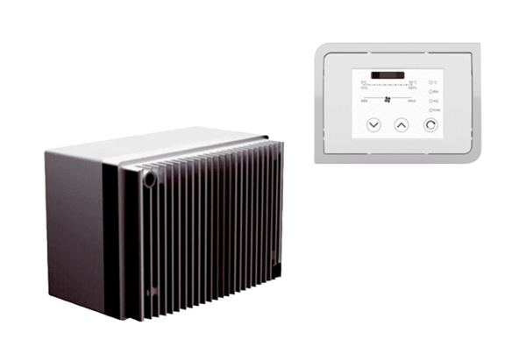Speed control system DRSPacking unit: 1 pieceRange: C
Article number: 0157.0188Manufacturer: MAICO

