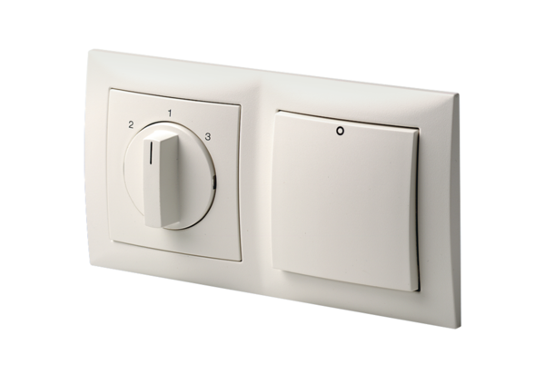Room air control RLS 3Packing unit: 1 pieceRange: K
Article number: 0157.0831Manufacturer: MAICO

