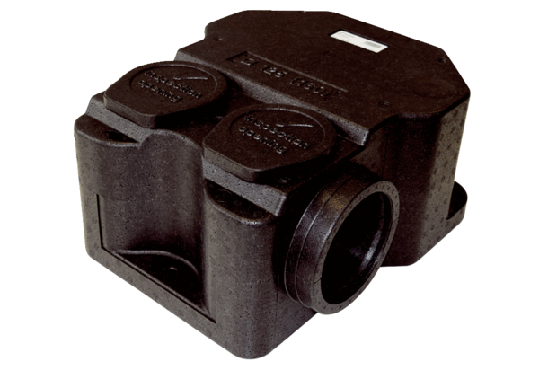Sound absorber box SB 12/16Packing unit: 1 pieceRange: K
Article number: 0059.0995Manufacturer: MAICO

