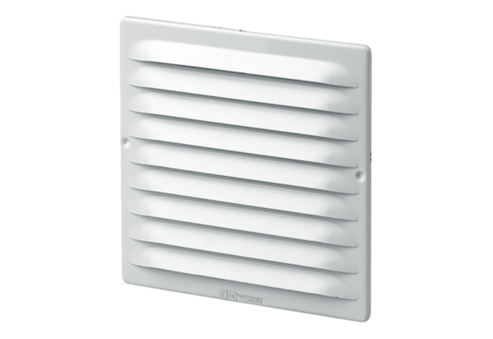External grille MGE 80/125 whitePacking unit: 1 pieceRange: K
Article number: 0078.0069Manufacturer: MAICO

