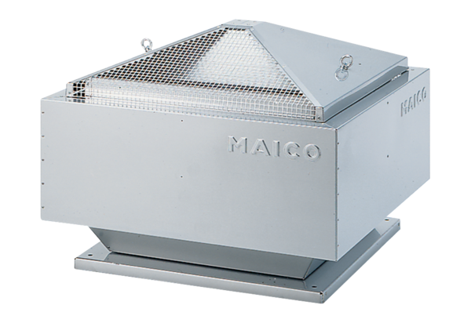Centrifugal roof fan GRD 31Packing unit: 1 pieceRange: C
Article number: 0087.0018Manufacturer: MAICO

