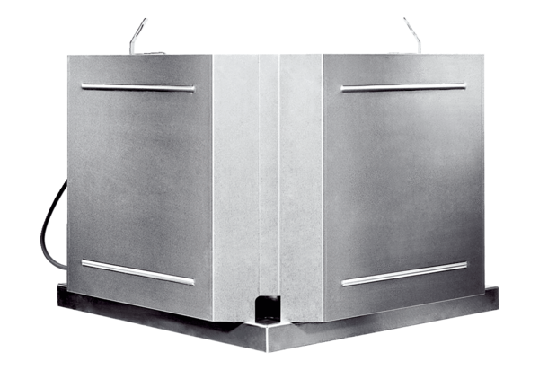Centrifugal roof fan DRD 31 ECPacking unit: 1 pieceRange: E
Article number: 0087.0172Manufacturer: MAICO

