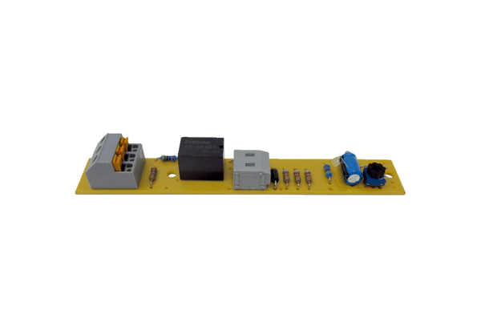Circuit board PL ECA 100 IRange: A
Article number: E101.1256.0000Manufacturer: MAICO

