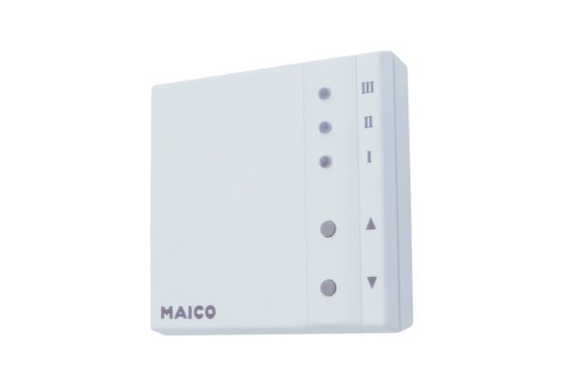Room air control RLS 1 WRPacking unit: 1 pieceRange: K
Article number: 0157.0809Manufacturer: MAICO

