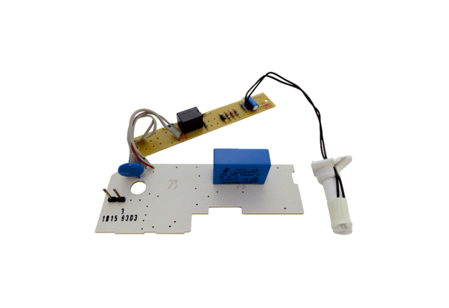Circuit board PL AP ER 100 FRange: B
Article number: E101.1015.9303Manufacturer: MAICO

