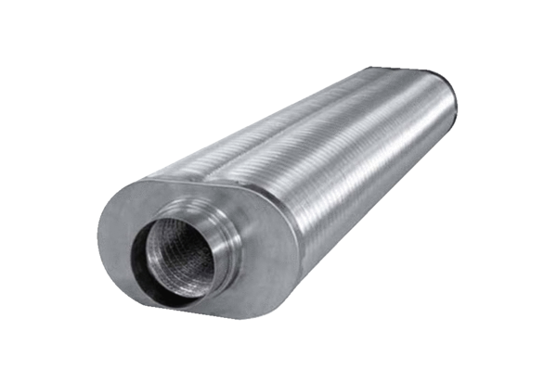Flat oval duct sound absorber RSOF 12/100Packing unit: 1 pieceRange: K
Article number: 0092.0534Manufacturer: MAICO

