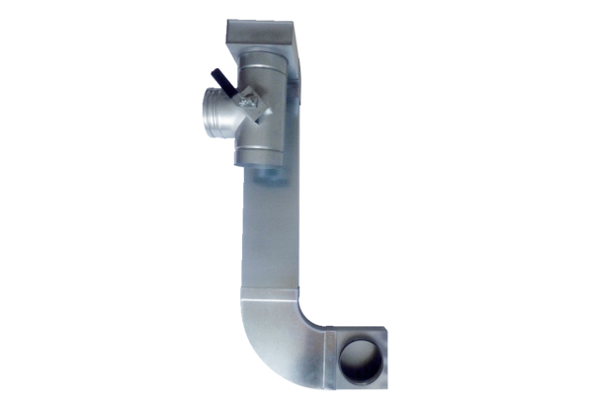Bypass for heat exchanger WRBY 300-400Packing unit: 1 pieceRange: K
Article number: 0093.0899Manufacturer: MAICO

