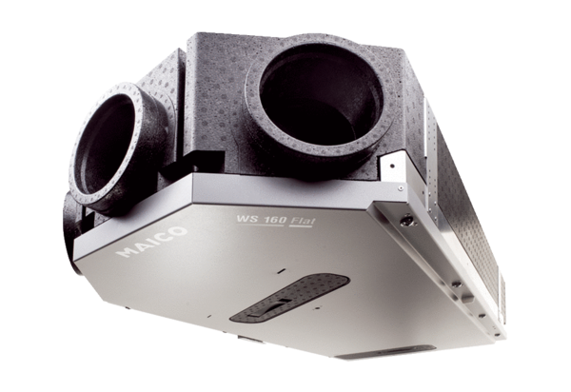Centralised ventilation unit WS 160 Flat KBETPacking unit: 1 pieceRange: K
Article number: 0095.0093Manufacturer: MAICO

