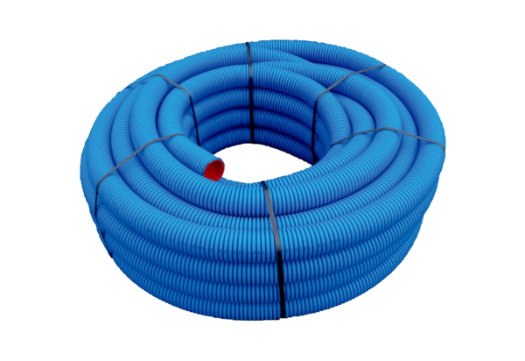Flexible duct MA-FR75Range: K
Article number: 0152.0091Manufacturer: MAICO

