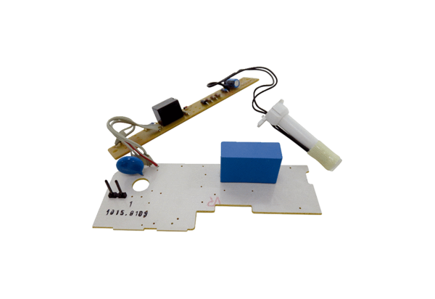Circuit board PL ER 100 FRange: B
Article number: E101.1015.9104Manufacturer: MAICO

