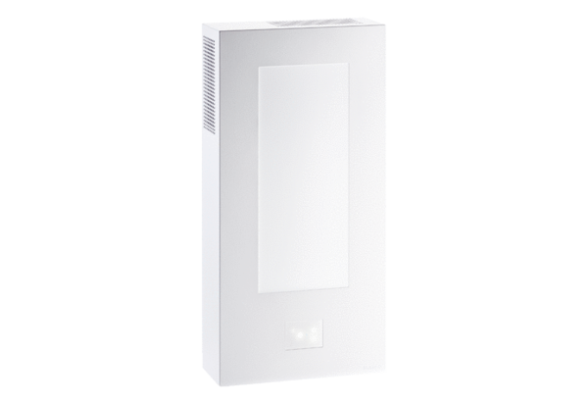Cover WS 75 APAPacking unit: 1 pieceRange: K
Article number: 0093.1617Manufacturer: MAICO

