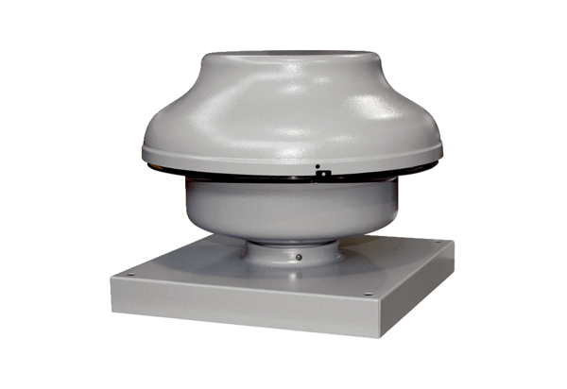Centrifugal roof fan EHD 15/2 ECPacking unit: 1 pieceRange: E
Article number: 0073.0591Manufacturer: MAICO

