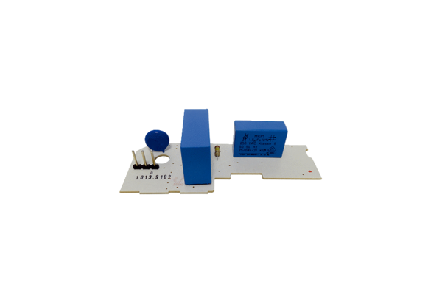Circuit board PL ER 100 GRange: B
Article number: E101.1013.9102Manufacturer: MAICO

