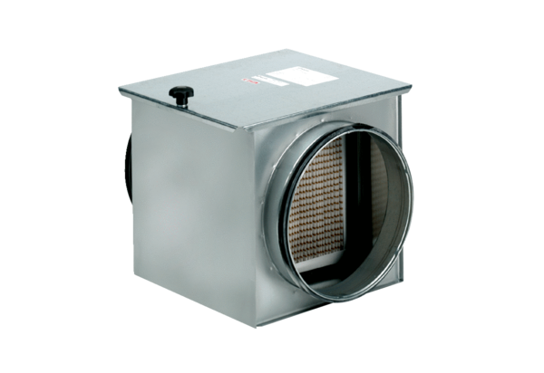Air filter TFE 40-5Packing unit: 1 pieceRange: C
Article number: 0149.0066Manufacturer: MAICO

