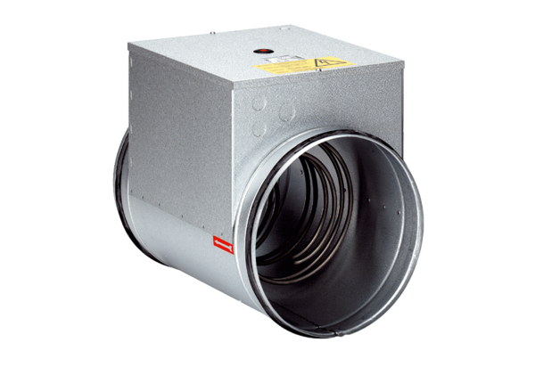Electrical air heater ERH 12-1Packing unit: 1 pieceRange: C
Article number: 0082.0101Manufacturer: MAICO

