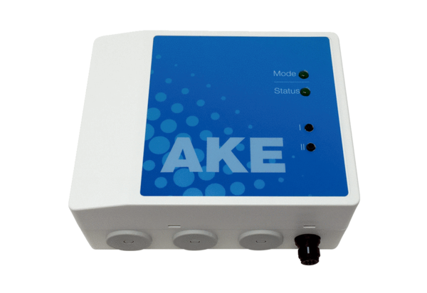Cellar dehumidification control AKEPacking unit: 1 pieceRange: A
Article number: 0157.0129Manufacturer: MAICO

