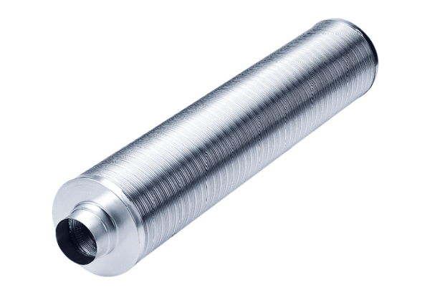Tubular sound absorber RSR 16/50Packing unit: 1 pieceRange: C
Article number: 0092.0324Manufacturer: MAICO

