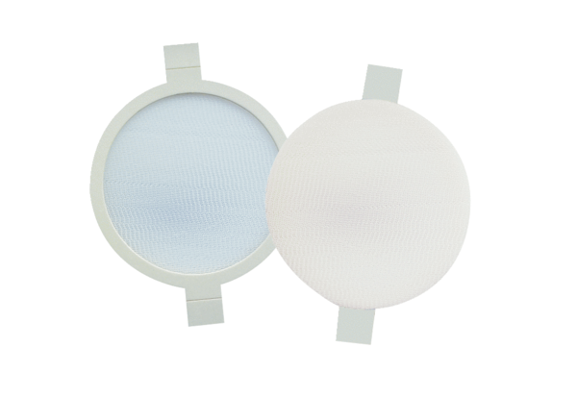Air filter, replacement PPF M6Packing unit: 2 piecesRange: K
Article number: 0093.0170Manufacturer: MAICO

