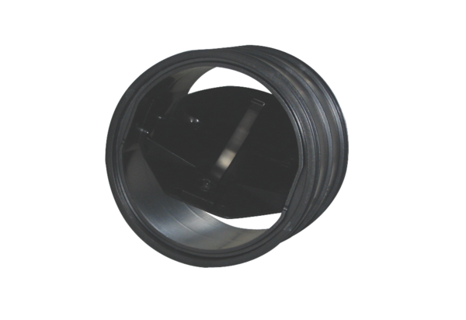Airstream limiter VSB 125Packing unit: 1 pieceRange: K
Article number: 0093.0110Manufacturer: MAICO

