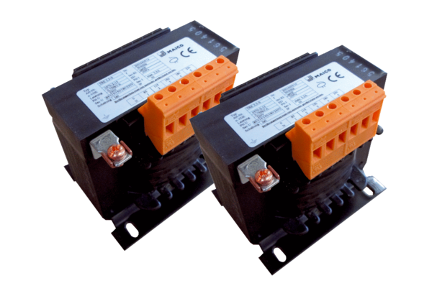5-step transformer, control cabinet TR 2,5 S-2Packing unit: 2 piecesRange: C
Article number: 0157.0152Manufacturer: MAICO

