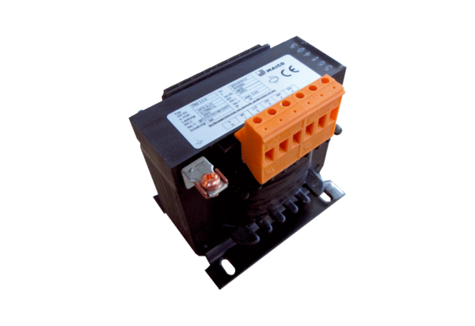5-step transformer, control cabinet TRE 3,3 S-2Packing unit: 1 pieceRange: C
Article number: 0157.0163Manufacturer: MAICO

