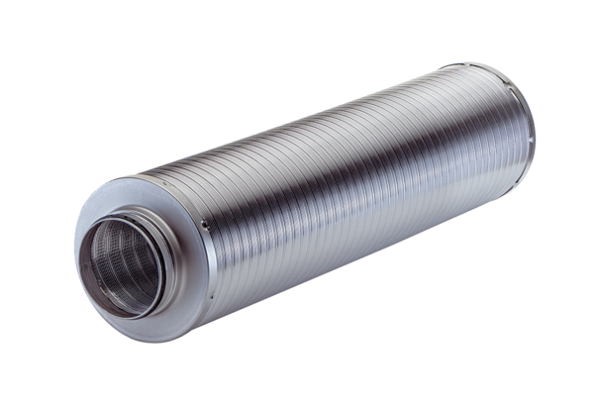Tubular sound absorber RSR 25-1Packing unit: 1 pieceRange: C
Article number: 0092.0598Manufacturer: MAICO

