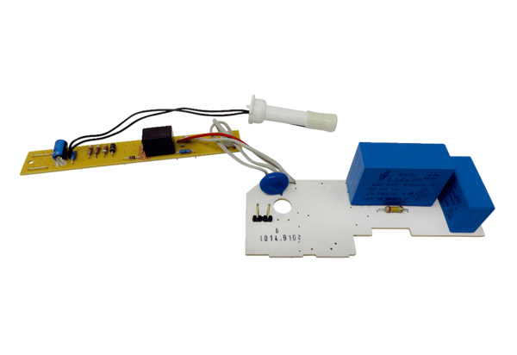Circuit board PL ER 60 FRange: B
Article number: E101.1014.9104Manufacturer: MAICO

