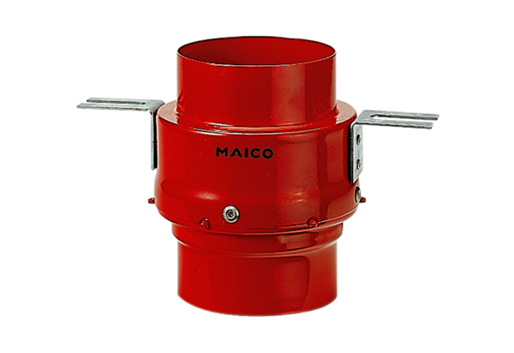Fire protection ceiling barrier TS 18 DN 125Packing unit: 1 pieceRange: B
Article number: 0151.0321Manufacturer: MAICO

