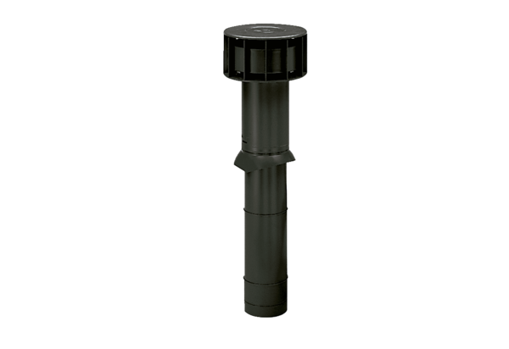Roof outlet DF 125 SPacking unit: 1 pieceRange: B
Article number: 0092.0374Manufacturer: MAICO

