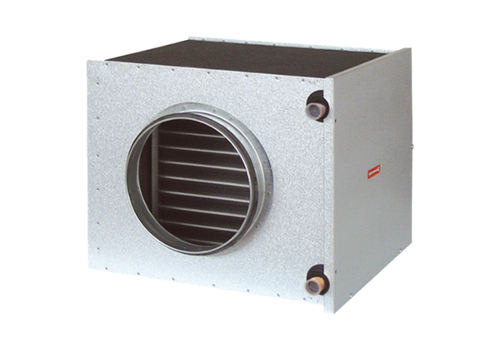Brine-air heat exchanger EW-K 200Packing unit: 1 pieceRange: K
Article number: 0192.0413Manufacturer: MAICO

