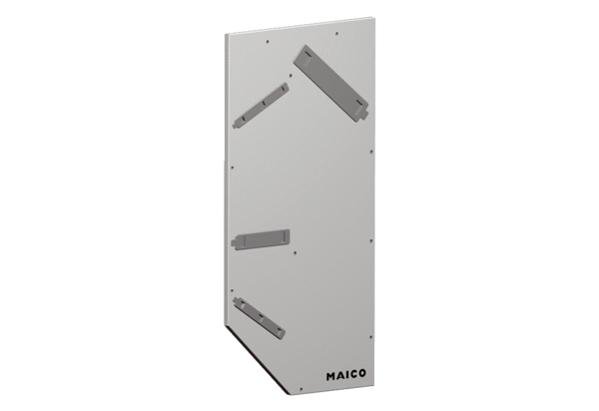Housing cover GD WS 75Range: K
Article number: E018.1396.0000Manufacturer: MAICO

