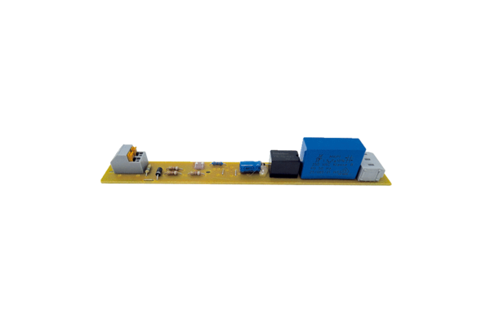Circuit board PL ECA 150 FRange: A
Article number: E101.1251.0000Manufacturer: MAICO

