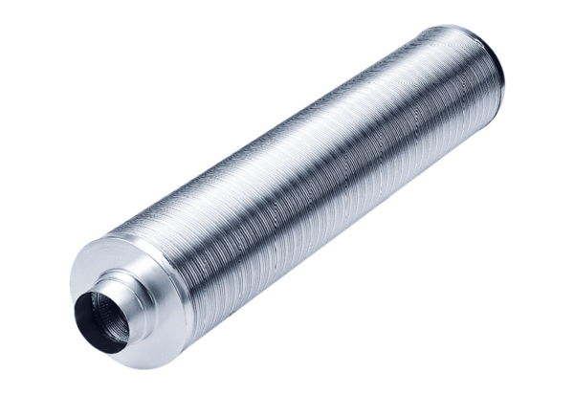Tubular sound absorber RSR 35/50Packing unit: 1 pieceRange: C
Article number: 0092.0335Manufacturer: MAICO

