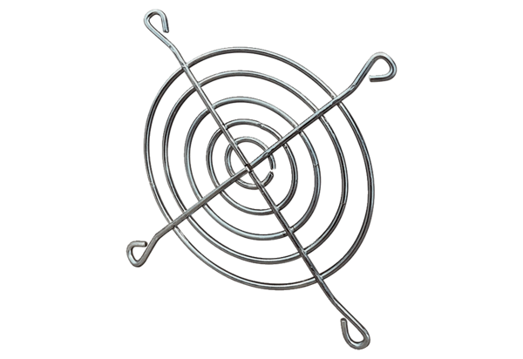Inlet protective grille SGEI 12Packing unit: 1 pieceRange: C
Article number: 0073.0285Manufacturer: MAICO

