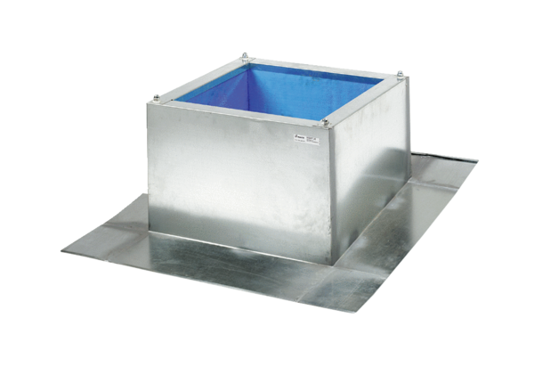Roof socket for corrugated and trapezoidal roofs SOWT 40Packing unit: 1 pieceRange: C
Article number: 0093.0988Manufacturer: MAICO

