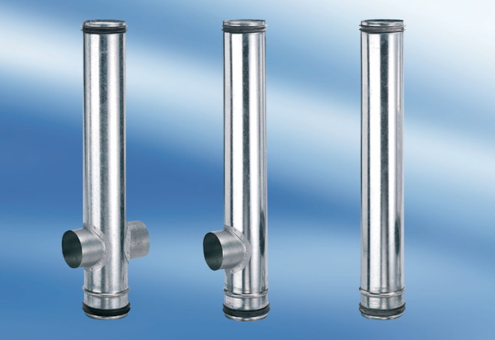BA 200/100-1Packing unit: 1 pieceRange: B
Article number: 0093.0054Manufacturer: MAICO

